Colonoscopy Prep Instructions Quick Guide
Split-Dose

{{#}} days before
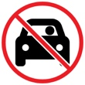 | You won’t be allowed to drive yourself home. Find someone who will drive you.
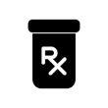 | Ask your doctor if you need to adjust your diabetes medicine or other prescriptions.
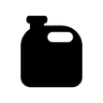 | Pick up the bowel prep medicine your doctor recommends.
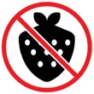 | Follow low-fiber diet instructions from your doctor.
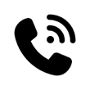 | Call us at {{PHONE_NUMBER}} if you have questions or need to cancel.

1 day before
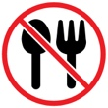 | Do not eat solid food today.
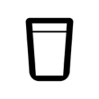 | Drink only clear liquids today.
  {{TIME}} | Start taking the first part of your prep medicine.
Day of your colonoscopy
 | Do not eat solid food today.
 | Drink only clear liquids today.
  {{#}} hours before | Start taking the rest of your prep medicine.
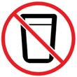
  {{#}} hours before | Stop drinking all liquids.

